Useful links:

1. <https://www.youtube.com/playlist?list=PLpklqhIbn1jqxYWVeB8VcIyna1psgbnYM>
2. M

Problem 1:

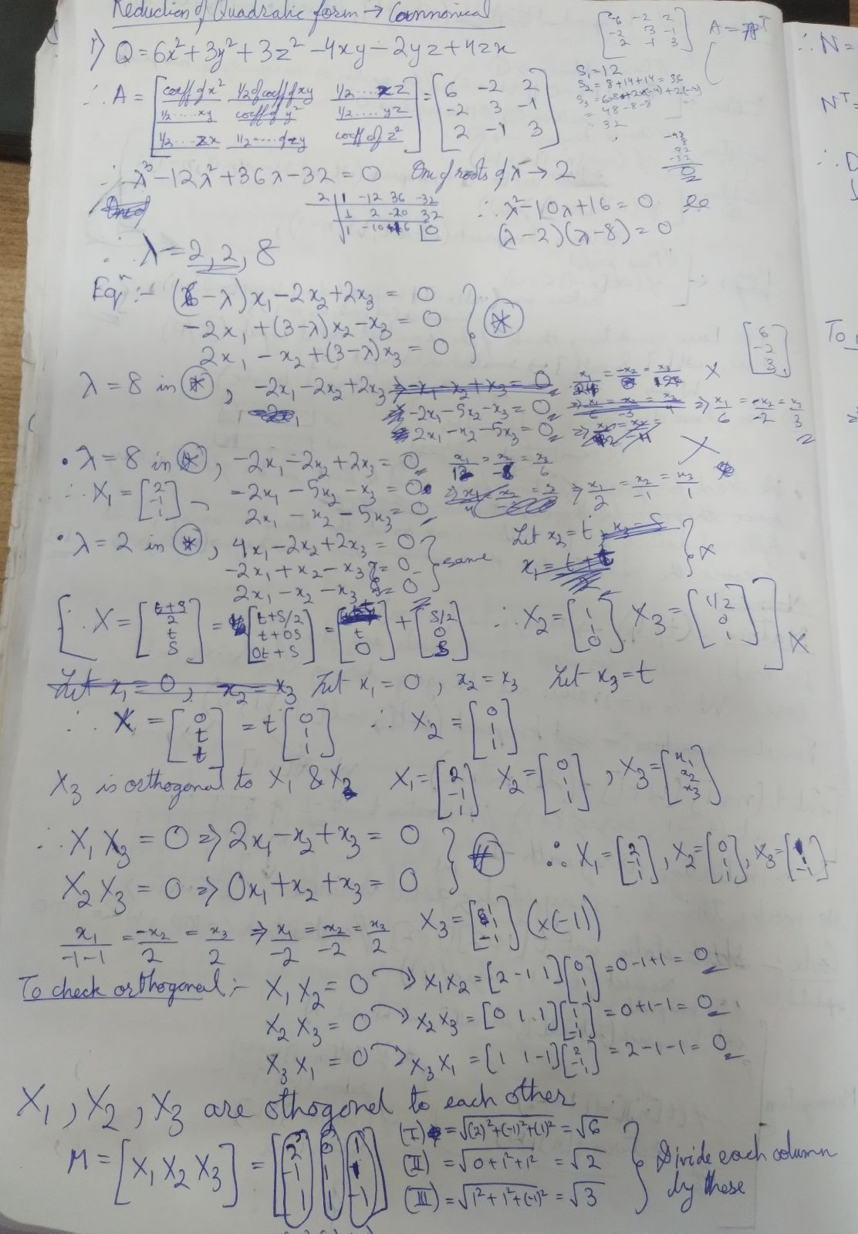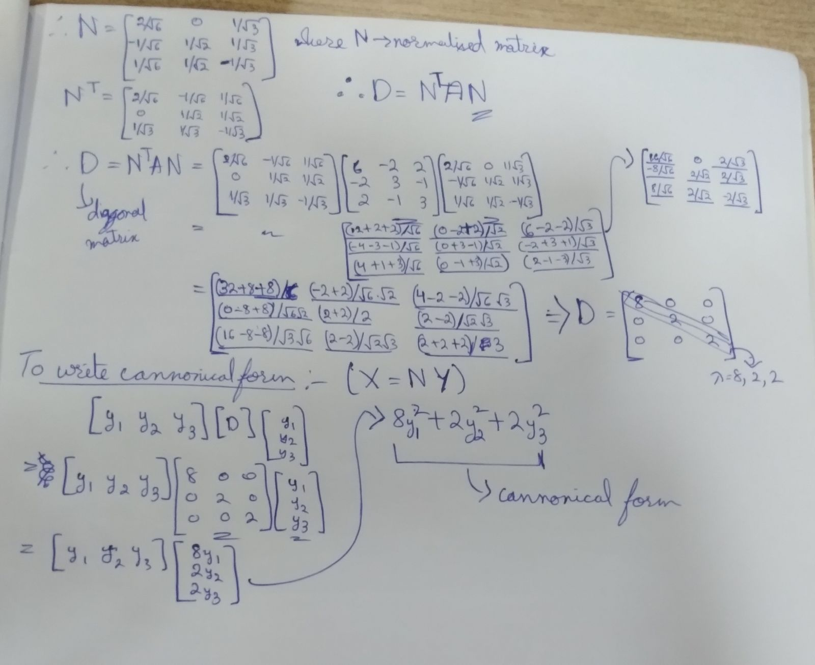

Things to remember:

* All eigen vectors are orthogonal to each other
* X1 x X2 = 0, X2 x X3 = 0 & X1 x X3 = 0
* M = [X1 X2 X3]
* Find roots of each column of M matrix
* N = M matrix divided by the corresponding roots
* D = diagonal matrix = N^T x A x N

Finding canonical form :

[y1 y2 y3] [D] [y1 y2 y3]

= y1^2 + y2^2 + y3^2 (canonical form)